Internal

Document Status:

Released by:

Revision / Document History

Ver. | Date | Changed by | Modifications
1.0 | 19/6/2024 | SDS/EIC | Initial Version
1.1 | 19/6/2024 | SDS/EIC | Reviewed and no change

List of Abbreviations
BGSW Bosch Global Software Technologies Private Limited

Table of Contents
1. Objective/Introduction 3
2. Scope 3
3. Brief Description 3
4. Others 3
5. Annexure 4

Introduction and Objectives - Executive Summary

BGSW desires to avail services from a suitable external Supplier to execute a part of above mentioned project.
All tasks should be executed from offshore Location at supplier premises.
The main objectives of this initiative are as follows:
Reduced Overall Costs: Utilizing Supplier services with best in class resources, increased productivity, and stringent project management principles to reduce the overall cost of the service, solution and ownership.
Quality Process: To understand and adopt where relevant, Supplier’s industry standard processes and standards to provide a high quality managed development service and achieve customer satisfaction
The long-term objective is also to build a reliable partner for this service and related services in future.

Scope of Work
Refer Annexure - 1

Not in Scope
Anything not mentioned as part of Annexure - 1

Service Hours
Refer Annexure – 1

Communication Model

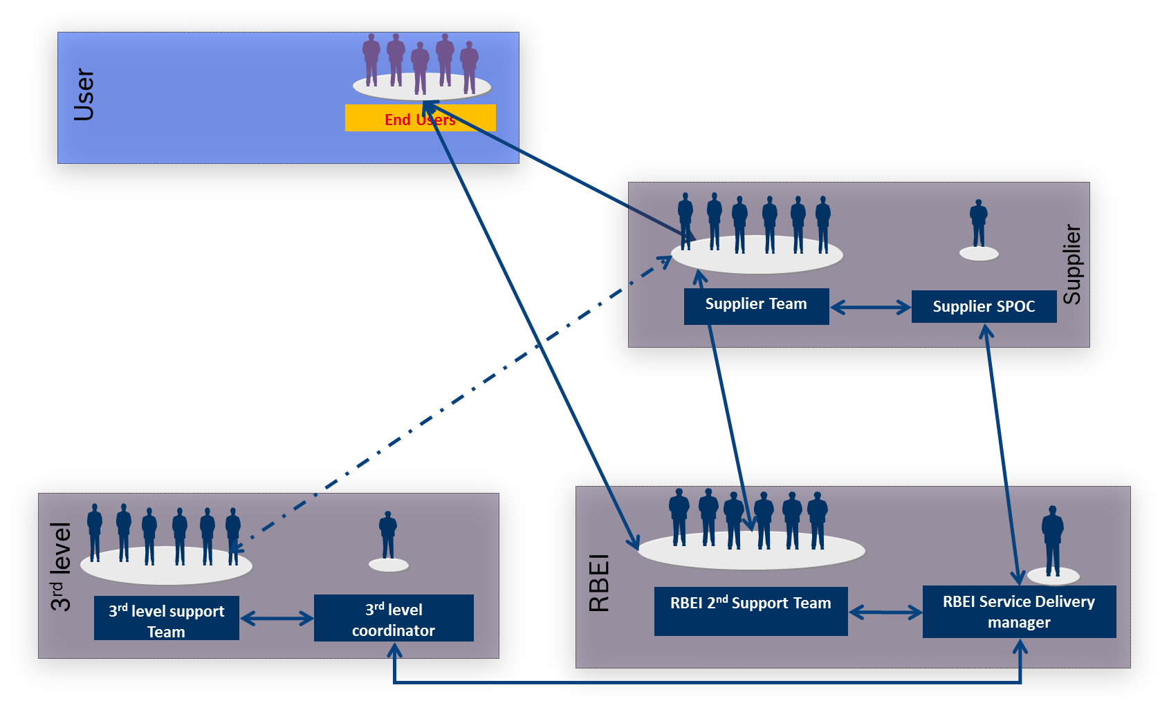

Target operating model
BGSW
BGSW – Delivery Head
BGSW – Service Delivery Manager
Partner – SPOC
Vendor
Partner first line Manager
Operating Model
Partner Team
Other Team

Role of the Vendor SPOC / Team Lead
- The SPOC is the single point of contact for the BGSW Service Delivery Manager for all activities of the Partner team
- The SPOC should possess the technical competence to deliver the defined scope of service with Quality
- The SPOC will be responsible for all the project deliverables of the team, from the initial transition phase, task allocation, tracking, BGSW QMS Adherence and clarifications
- The SPOC should review the effectiveness of support handled by the Partner team and ensure quality of the deliverables with in SLA
- The SPOC will be responsible for milestone deliveries and obtain sign-off for the same if any
- The SPOC will handle all coordination and administrative activities necessary to support the Partner team
- The SPOC – will give Weekly (every First working day of the week) and monthly status report (MSR) to BGSW Service Delivery Manager before 6th of every month in BGSW Specific format. Feedback of MSR will be provided by BGSW Delivery Manager or Service Delivery Manager
- SPOC experience match with BGSW basic criteria
- Mandatory to furnish Experience details (detailed resume) and approval with BGSW before deployment
Replacement of SPOC consultant with 3 months’ notice and release upon BGSW SDM confirmation on know-how completion & independent support readiness of new resource
The detailed responsibilities from project perspective are elaborated in a subsequent section of the RFP.

Role of the Vendor – First Line Manager
The vendor-FLM will be responsible for the overall engagement of the Supplier with BGSW. The expectation is to be the single point of contact for BGSW for the following aspects:

- Nomination of suitable resources and facilitate evaluation by BGSW
- Support initial induction of the Supplier team
- Tracking the progress of the ScPL on project deliverables
- First Escalation level by BGSW on any issues
- Support to ScPL on any issue
- Handling changes in scope, resources and any other issues related to the Supplier’s area of activity

Project Organization with respect to Supplier
As depicted in Fig. below, the Supplier team will function as project team of BGSW, headed by the BGSW Service Delivery Manager.

BGSW – Service Delivery Manager
Vendor SPOC
Team Member1
Team Member2

Service Targets
KPI | Target | Impact
Refer Annexure 1

2.1 Service Level Reporting

Communication Type / Media | From | To | Frequency | Things to be discussed
Monthly status reporting | Partner SPOC | BGSW Service Delivery Manager,  BGSW Partner Manager & BGSW Department Head  (presence if there are valid issues affecting the Operation / Service Delivery) | Monthly | - Monthly Status Report with Feedback template.  - Content Review Feedback  - Resource & Knowledge retention Risks (if any)

2.2 Service Level Review

Communication Type / Media | From | To | Frequency | Things to be discussed
Senior Management Review | Partner Program Manager | BGSW Service Delivery Manager  BGSW Department Head  BGSW Partner Manager | Bi-Monthly | - Open Issue / Escalation  - Progress of Service  - KPI targets and Breaches  - Project Status Feedback  - Area of Improvement

Escalation Matrix

BGSW Service Delivery Manager
Supplier Mointoring SPOC

BGSW Partner Manager
Supplier First Line Manager

BGSW – Senior Management
Supplier Senior Management
Supplier Support Team
1st Level Escalation
2nd Level Escalation
3rd Level Escalation

3.1 Skill requirements

Please Refer Annexure -1

Delivery Model

4.1 Deliverables

Please Refer Annexure -1

4.2 Acceptance criteria

- On time and error free delivery of all Activities mentioned in SCOPE OF WORK
- Reliable and Suitable Candidates should be selected to perform the tasks
- Partner team to ensure followed the central guidelines and process as defined by BGSW Service Process Management along with any other applicable customer process.
- Process adherence deviation should be <0.5%. Process audits will be done quarterly once inline to BGSW QMS guidelines
- Business continuity plan shall be planned to ensure service continuity without fail
- In case partner team is not capable to deliver the deliverable on time or the quality of the deliverables are not satisfactory, Any damages due to this Partner need to take the responsibility to fix the damages within the agreed timelines. BGSW Service delivery Manager and BGSW Partner Manager shall have an escalation meeting to decide next course of actions alongwith Partner –FLM/Mgt. and Progress of the same will be tracked till closure.
- 2% of the monthly invoice value of that particular module for which breach has gone beyond agreed KPI’s limits will be forfeited

- If partner team member is resigned / absconding from work BGSW Service delivery manager should get information ASAP and alternative arrangement made available to ensure the agreed deliverables are met
- External partner should provide a suitable action plan / Transition plan in proposal for associate attrition and absconding cases

4.3 Roles and Responsibilities

External partner
Role | Responsibility
Partner SPOC | - Responsible for all deliverables of the Partner Team  - Prepare internal resource allocation plan  - Monitor all project activities  - Escalation management  - Submit project related reports and status reports to BGSW Service Delivery Manager  - Relevant activities as per BGSW QMS processes  - Develop reports as per requirements
Partner Team Member | - Execute the function scope and service description as mentioned in scope section
BGSW
Role | Responsibility
BGSW Service Delivery Manager | - Regular Status reviews with Partner SPOC on service progress  - Guiding the Partner SPOC on complex issues  - Approval and clearing of invoices
BGSW Partner manager | - Periodical status reviews with partner account managers on service progress

4.4 Quality Assurance
The Supplier team should comply with the Software Quality Assurance (SQA) Plan for every project. Our Approach to SQA for every engagement covers the following:

1. Product and Process Standards to be adopted
2. Work Product Review plan
3. Frequency of Audits to ensure quality compliance
4. Quality Assurance reporting that includes:
- Internal Quality audit report
- Metrics report
- Process Compliance report
- Having local copy of data or Data Sharing to external parties are against policy violation and External team to adhere on the confidentiality.

4.5 Project Communication

Communication Type / Media | From | To | Frequency | Things to be discussed
Daily Status reporting | Partner SPOC | BGSW Service Delivery Manager | Daily | Project status Issues  Daily Status Report  Ageing and action update
Weekly status reporting | Partner SPOC | BGSW Service Delivery Manager | Weekly | - Weekly Status Report  - KPI Statistics  - Knowledge gaps  - RCA, Measures & Improvements on Delivered Defects, Escalations, Customer Complaints.

Resource requirements

5.1 Human resources
As per Annexure - 1

5.2 Hardware resources

Partner shall ensure required hardware will be taken care in order to meet the agreed service deliverables, in case of any project specific hardware BGSW will provide the same.

5.3 Software resources

Partner shall ensure required Software will be taken care in order to meet the agreed service deliverables, in case of any project specific software BGSW will provide the same.

5.4 Transition

In case of any resource changes during project, partner has to take care for KT and smooth transition

Below is “Phase IN & OUT” strategy for new resource needs to introduced New member to project or release from project

Roles and responsibilities

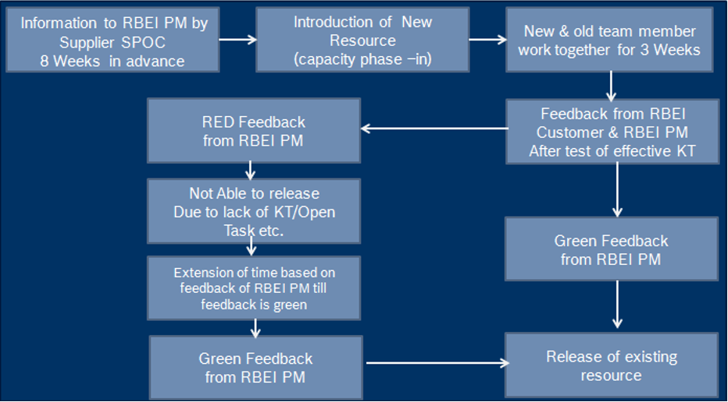

Topics | Responsible | Remarks
Information to BGSW Project Manager | Supplier SPOC
Introduction of new resource | Supplier SPOC
Knowledge Transfer | Old Associate
Task Take over | New Associate
Validation of change over and information to BGSW PM | Supplier SPOC
Post transition Performance Validation of Change | BGSW PM

Commercial Proposal

Supplier is to provide commercial proposal as per the applicable below format:

- In case of ODC Operations:

Phase | Capacity | Minimum Seats for billing (number) | Cost per Seat (in INR per month)

- In case of Work package execution

Requirement ID | Work package deliverable detail | Effort Estimation (PMO) | Deliverable cost (TINR)
Total Cost of Work Package (TINR)
Average Cost of Work Package /PMO

Annexure

- Annexure – 1 : Requirement Details
- Annexure - 2 : Service Delivery Template

Robert Bosch Engineering and Business Solutions Pvt Ltd.
Competency Requirement Sheet (Annexure -1)


Work Package (Competency required) | Skill : Power Platform Developer
Language (Non English if any) | NA
Work Location | Bangalore
Years of exp | 3+
Department / Group | SDS/EIC
No.of resources | 3
Expected Start Date | Immediate
Expected Project Duration (month) | 12 Months
Service Hours (working time/shift/ time zone) | Indian Standard time
BGSW Delivery Responsible | Suvendu Nayak (SDS/EIC1)
Education and Work Experience Requirements:

- Primary Skill Set:
  - Good experience in SharePoint Online customization and out of the box features (M365).
  - Extensive and hands-on development experience in Microsoft Power Platform - Power Apps (Canvas & Model Driven Apps) and Power Automate.
  - Experience in customizing SharePoint Online lists forms with Power Apps and Power Automate.
  - Experience working with Dataverse tables, security roles and groups.
  - Experience working in JSON formatting including list formatting, column formatting etc. in SharePoint Online (out of the box features)
  - Good knowledge about the Power Platform environment and solutions (including deployment).
  - Knowledge in developing and configuring custom connectors.
  - Hand-on experience in developing PCF (Power Apps Component Framework) and other reusable components. Hands-on experience in TypeScript and React JS.
  - Hands-on experience in SharePoint out-of-the-box features, SharePoint Framework (SPFx) and PnP webparts. Good knowledge in React JS and TypeScript.
  - Basic knowledge on Power BI.

- Secondary Skill Set:
  - Experience in integration with 3rd party systems (e.g. – SAP etc.).
  - Installation and configuration of data gateways.
  - Data Migration experience.
  - Azure Cloud technologies (Functions, Logic Apps, AD).

- Good To Have –
  - Power Platform (PL-400), M365 and Azure certifications

- Excellent communication, collaboration, and mentoring skills.

- Proficient working in Agile (Scrum) project methodologies.

- Experience working across disciplines, groups, and teams.

Annexure - 2 : Service Delivery Template

